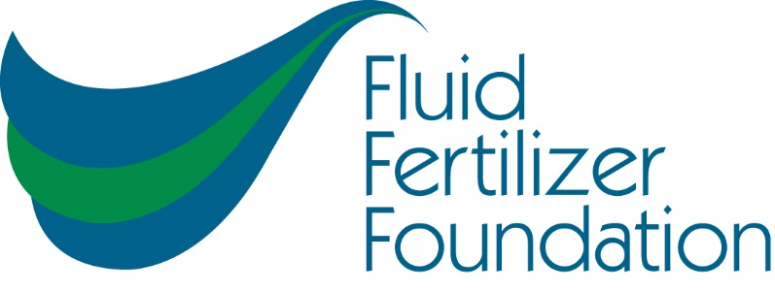
Fluid Fertilizer Foundation
Technology Workshop
December 11 & 12
Ameristar Hotel and Casino
Agenda
Time Topic
Dec. 11
10:00 AM Registration Open
12:20 PM Welcome and Announcements
12:30 PM Lessons Learned, Safety is for Everyone
1:20 PM Water Issues facing agriculture
1:50 PM Automation technology and process control
2:40 PM Break
3:10 PM Fertilizer Formulation
4:00 PM Plumbing and piping
4:50 PM Winter salt out and freezing issues. Storage and compatibility Properties of different formulations
5:30 PM Reception
7:00 PM End of day
Dec. 12
8:00 Y Drop research and rationale
8:30 AM Precision Seed & Fertilizer Application Systems
9:20 AM Break
9:50 AM Bundling Liquid Starter Fertilizers to Improve Nutrient Use Efficiency
10:20 AM Cover crop steps to success
10:50 AM Tips on staying out of Court
11:20 AM Banding Liquids
12:10 PM Adjourn

